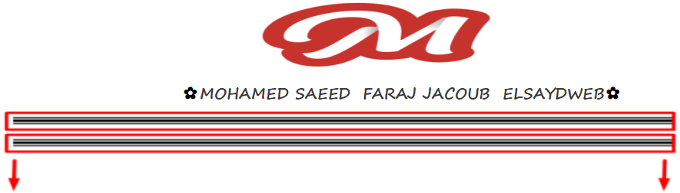



طريقه عمل border جميل زى ده

مع شرح السيشن او كود السيشن

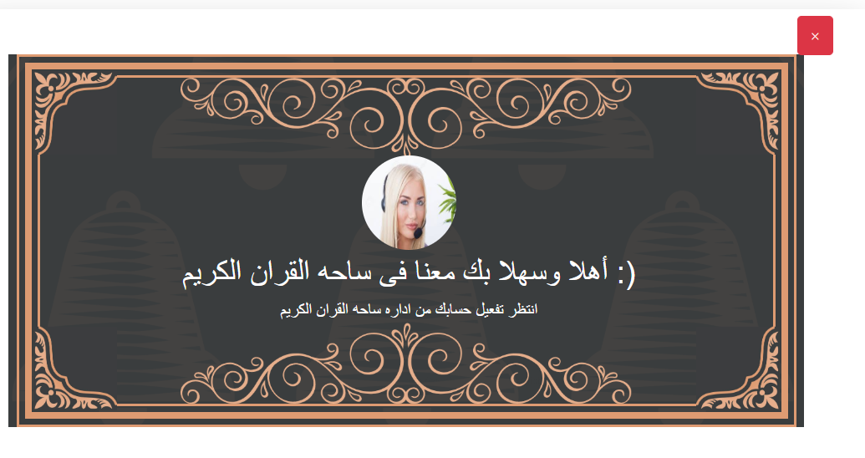

ده ال html

<div class="alert alert-block content_MULTIPLE_BORDERS">  
  
 <button type="button" class=" btn btn-danger btn_close_BORDERS " data-dismiss="alert">×</button>  
  
  
 <aside>  
 <div class="body dark-background" style=" background-image: url(https://i.ibb.co/nrmkm7d/five-bells-washed-out-logo.png) , linear-gradient(to right, rgba(58, 61, 62, 1) 0%, rgba(58, 61, 62, 1) 100%);">  
 <div class="outer-border">  
 <div class="mid-border">  
 <div class="inner-border">  
 <img class="corner-decoration corner-left-top" src="https://i.ibb.co/4mKvK3N/corner-decoration.jpg"></img>  
 <img class="corner-decoration corner-right-top" src="https://i.ibb.co/4mKvK3N/corner-decoration.jpg"></img>  
 <img class="corner-decoration corner-right-bottom" src="https://i.ibb.co/4mKvK3N/corner-decoration.jpg"></img>  
 <img class="corner-decoration corner-left-bottom" src="https://i.ibb.co/4mKvK3N/corner-decoration.jpg"></img>  
 <img class="vertical-decoration top" src="https://i.ibb.co/JRTK9z4/horizontally-centered-vertical-decoration.png"></img>  
 <img class="vertical-decoration bottom" src="https://i.ibb.co/JRTK9z4/horizontally-centered-vertical-decoration.png"></img>  
  
 <!-- Page Content -->  
 <div class="container">  
 <div class="row social-row">  
 <a href="#" target="_blank" class="d-none" style="background-image: url(https://i.ibb.co/k0JQYv4/instagram-social-button.png)"></a>  
  
 </div>  
 <div class="row">  
 <div class="col-lg-12 text-center">  
 @if(session()->has('image'))  
  
 <img class="image_user_register m_t_70px" src="storage/teachersignup/{{ Session::*get*('image') }}" alt="Five Bells logo">  
 @else  
 @foreach($setting as $sett)  
 <div class=" "><img class="image_user_register m_t_70px" src="storage/{{$sett->logo}}" alt="Five Bells logo"></div>  
 @endforeach  
 @endif  
  
  
 <h1 class="text-uppercase white-text countach">{{trans('admin.welcome_to_quransquare')}}</h1>  
 <h6 class="text-uppercase text_Wait_for__account countach">{{trans('admin.Wait_for_your_account_to_be_activated')}}</h6>  
 <p class="lead skintone-text">  
 {{-- <span class="name skintone-text countach">Add your own washed</span>--}}  
 {{-- <span class="place skintone-text tilda-petite">Creative Logo<span>--}}  
 </p>  
  
 </p>  
 </div>  
 </div>  
 </div>  
 </div>  
 </div>  
 </div>  
 </div>  
 </aside>  
  
  
  
  
  
</div>

وده ال css

.image_user_register  
{  
 width: 100px;  
 height: 100px;  
 border-radius: 50%;  
 /*border: 1px solid #444;*/  
 padding: 5px;  
}.image_user_register.m_t_70px  
{  
 margin-top: 70px;  
  
 }  
 @media(max-width: 992px)  
 {  
 .image_user_register.m_t_70px  
 {  
 margin-top: 50px;  
  
 }  
 }  
  
/*-------------------------start MULTIPLE BORDERS VINTAGE FRAME ---------------*/  
.btn_close_BORDERS{  
 margin-left: -7px;  
 margin-top: -37px;  
}  
.content_MULTIPLE_BORDERS{  
 margin-top: 30px;  
 margin-bottom: -38px;  
}  
:root {  
 --skintone-color: #DE9B72;  
 --dark-color: #3A3D3E;  
}  
  
.main {  
 height: 100%;  
}  
  
  
  
  
.body {  
 height: 100%;  
 display: flex;  
 justify-content: center;  
 flex-direction: column;  
 background-size: 140%**!important**;  
 background-repeat: no-repeat **!important**;  
 background-position: center **!important**;  
}  
  
@media (min-width: 992px) {  
 .body {  
 background-size: 148vh**!important**;  
 background-repeat: no-repeat **!important**;  
 background-position: 50% -31vh**!important**;  
 }  
}  
  
.row {  
 margin-right: 0;  
 margin-left: 0;  
}  
  
.social-row {  
 display: flex;  
 flex-direction: column;  
 right: 0;  
 position: absolute;  
}  
  
@media (min-width: 768px) {  
 .social-row {  
 position: relative;  
 flex-direction: row;  
 justify-content: flex-end;  
 }  
}  
  
.social-row a {  
 width: 2em;  
 height: 2em;  
 background-repeat: no-repeat;  
 background-size: contain;  
 padding: 1em 0;  
 z-index: 99;  
 margin-bottom: 1em;  
 margin-right: 1em;  
}  
  
@media (min-width: 768px) {  
 .social-row a {  
 width: 2.5em;  
 height: 2.5em;  
 padding: 1em 0;  
 margin-bottom: 0;  
 }  
}  
  
@media (min-width: 1200px) {  
 .social-row a {  
 width: 3em;  
 height: 3em;  
 padding: 0;  
 }  
}  
  
.countach {  
 font-family: countach,sans-serif;  
 font-weight: 400;  
 font-style: normal;  
}  
  
.tilda-petite {  
 font-family: tilda-petite,sans-serif;  
 font-weight: 400;  
 font-style: normal;  
}  
  
.montserrat {  
 font-family: montserrat, sans-serif;  
 font-weight: 300;  
 font-style: normal;  
}  
  
.skintone-text {  
 color: var(--skintone-color);  
}  
  
.dark-text {  
 color: var(--dark-color);  
}  
  
.white-text {  
 color: #fff;  
 font-size: 30px;  
 margin-bottom: 33px;  
}  
.text_Wait_for__account{  
 color: #fff;  
 font-size: 19px;  
 margin-top: -25px;  
 margin-bottom: 45px;  
}  
  
  
a:hover {  
 color: #c2c2c2;  
}  
  
.dark-background {  
 background: var(--dark-color);  
}  
  
  
.logo {  
 width: 20vh;  
}  
  
@media (min-width: 768px) {  
 .logo {  
 width: 16em;  
 }  
}  
  
@media (min-width: 992px) {  
 .logo {  
 width: 18em;  
 }  
}  
  
@media (min-width: 1200px) {  
 .logo {  
 width: 28vh;  
 height: 28vh;  
 }  
}  
  
  
  
@media (min-width: 992px) {  
 h1 {  
 font-size: 2.75em;  
 }  
}  
  
@media (min-width: 1200px) {  
 h1 {  
 font-size: 3em;  
 }  
}  
  
.lead {  
 font-size: 1.5rem;  
 padding-top: 0.5em;  
}  
  
@media (min-width: 992px) {  
 .lead {  
 font-size: 2rem;  
 padding-top: 0.5em;  
 }  
}  
  
@media (min-width: 1200px) {  
 .lead {  
 font-size: 2.5rem;  
 padding-top: 1em;  
 }  
}  
  
p.general {  
 font-size: 2.5vh;  
 margin-bottom: 0.5em;  
 line-height: 1.25em;  
}  
  
@media (min-width: 992px) {  
 p.general {  
 font-size: 1.25em;  
 line-height: 1.5em;  
 }  
}  
  
@media (min-width: 1200px) {  
 p.general {  
 font-size: 1.5em;  
 }  
}  
  
  
.inner-border {  
 display: flex;  
 justify-content: center;  
 flex-direction: column;  
}  
  
.outer-border {  
 border: 2px solid #DE9B72;  
 height: 99%;  
 width: 98%;  
 padding: 6px;  
 margin: 0 auto;  
}  
  
@media (min-width: 992px) {  
 .outer-border {  
 height: 94%;  
 }  
}  
  
.mid-border {  
 border: 6px solid #DE9B72;  
 height: 100%;  
 width: 100%;  
 padding: 6px;  
 margin: auto;  
}  
  
.inner-border {  
 position: relative;  
 border: 2px solid #DE9B72;  
 height: 100%;  
 width: 100%;  
 margin: auto;  
}  
  
  
/* Decorations */  
.corner-decoration {  
 position: absolute;  
 width: 3em;  
 margin: -3px;  
}  
  
@media (min-width: 768px) {  
 .corner-decoration {  
 width: 3.5em;  
 margin: -4px;  
 }  
}  
  
@media (min-width: 992px) {  
 .corner-decoration {  
 width: 4em;  
 margin: -5px;  
 }  
}  
  
@media (min-width: 1200px) {  
 .corner-decoration {  
 width: 5em;  
 margin: -6px;  
 }  
}  
  
.corner-decoration.corner-left-top {  
 left: 0;  
 top: 0;  
}  
  
.corner-decoration.corner-right-top {  
 top: 0;  
 right: 0;  
 -webkit-transform: scaleX(-1);  
 transform: scaleX(-1);  
}  
  
.corner-decoration.corner-right-bottom {  
 right: 0;  
 bottom: 0;  
 -webkit-transform: scale(-1);  
 transform: scale(-1);  
}  
  
.corner-decoration.corner-left-bottom {  
 left: 0;  
 bottom: 0;  
 -webkit-transform: scaleY(-1);  
 transform: scaleY(-1);  
}  
  
  
.vertical-decoration {  
 position: absolute;  
 left: 0;  
 right: 0;  
 margin: auto;  
 width: 11em;  
}  
  
  
@media (min-width: 768px) {  
 .vertical-decoration {  
 width: 16em;  
 }  
}  
  
  
@media (min-width: 992px) {  
 .vertical-decoration {  
 width: 20em;  
 }  
}  
  
@media (min-width: 1200px) {  
 .vertical-decoration {  
 width: 27em;  
 }  
}  
  
.vertical-decoration.top {  
 top: 0;  
  
}  
  
.vertical-decoration.bottom {  
 bottom: 0;  
 -webkit-transform: scaleY(-1);  
 transform: scaleY(-1);  
}  
  
/*-------------------------End MULTIPLE BORDERS VINTAGE FRAME ---------------*/

وده كود الcontrooler

if (request()->hasFile('icon')) {  
  
  
 $imageName = time() . '.'.request()->icon->getClientOriginalExtension();  
  
 request()->icon->move(public_path('storage/teachersignup'), $imageName);  
 request()->icon= request()->icon->getClientOriginalExtension();  
 session()->forget('image');  
 TeacherSignup::*create*($data);  
  
 return back()  
 ->with('success', 'You have successfully upload image.')  
 ->with('image', $imageName);  
 }else{  
 $imageName = '';  
 }  
  
  
  
 TeacherSignup::*create*($data);  
  
 return back()  
 ->with('success', 'You have successfully upload image.')  
 ;  
}

<https://codepen.io/chris_tudor/pen/OJPeQgb>

كل الفكره بتعمل سيشن بترجع بى ال imgو ال name الى انت عملتهم وبتجيبهم فى الرساله بتعتك الجميله وبتتعرض بى الشكل ده

